## INTRODUCTION

We have 252 trading days of historical data for the historic stocks "APPL (Apple Inc)" and "HON (Honeywell Inc)." We have the closing price and volume for each stock at the time of trade. Furthermore, in order to complete the work at hand, we must use time series forecasting techniques and illustrate why they are beneficial for predicting. We'll divide this project into three components to make it easier to understand while answering some questions as we go through each of these components:

**• Short-term forecasting**

**• Long-term forecasting**

**• Simple Regression Analysis**

## ANALYSIS

## Part One: Short-term forecasting

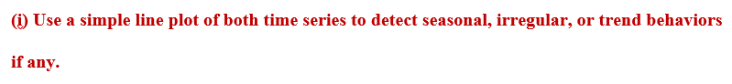

I plotted the closing prices of the APPL (Apple Inc) stock for 252 trading days using the line plot. For example, the stock closing price on December 8th was $63.95, and within a few days, it had grown to over $80.00. After that, the price dropped to less than $60.00, but it has been steadily rising since then, peaking at $130.00 and presently hovering around the $120.00 mark. I also added a trend line so that we can see that the plot has been trending upward. To forecast this pricing environment, we'll use techniques like moving averages and exponential smoothing.

Using the line plot, I plotted the closing prices of the HON (Honeywell Inc) stock for 252 trading days. For example, on December 8th, the stock closed at $177.03, and after maintaining that closing price for a few weeks, it fell to its lowest point, which was around $100.00. But it's been steadily rising since then, and it now has the highest closed stock price when we utilized its most recent closing date, which was approximately $185.00. I also included a trend line to show that the plot has a consistent trend line that is slightly descending. To forecast this pricing environment, we'll use techniques like moving averages and exponential smoothing.

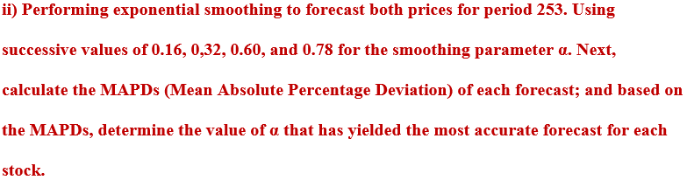

Calculate the mean absolute percentage deviation (MAPD) values for each APPL and HON closing price stock first. We do this by talking out their forecast values for each of the alpha values and then calculating their absolute deviation values, then finally we calculate the MAPD value which is the average of the total absolute value. This whole process is known as Exponential smoothing

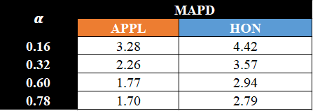

We made a table with all of the MAPD values for each forecasted alpha value, and we can see that for both APPL and HON, alpha = 0.78 has the lowest deviation value. As a consequence, we'll use alpha = 0.78 for short-term forecasting because it has the lowest standard deviation.

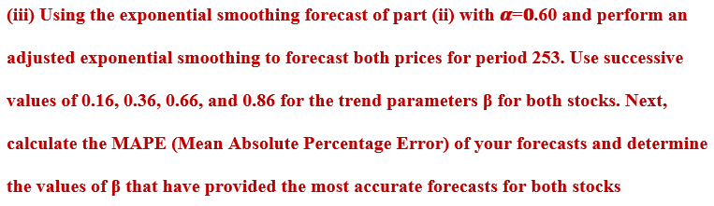

First, determine the mean absolute percentage error (MAPE) for each APPL and HON closing price. We achieve this by calculating our trend values using different beta values based on the forecasted value we acquired in the previous task on alpha = 0.60. Then adding those trend values with our forecasted values we’ll take out their relative absolute error by subtracting our value with the original closing stock value and dividing it by the closing stock value as well. Finally, we’ll take out the average and this will provide us with the MAPE value which we will represent in percentage. This whole process is known adjusted exponential smoothing.

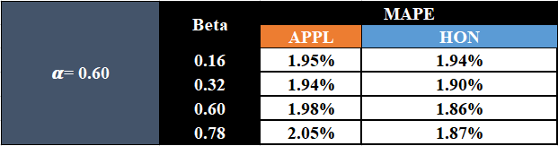

We made a table with all of the MAPE values for each forecasted beta value on alpha = 0.60, and we can notice that for APPL beta = 0.32 has the lowest percentage value while for HON beta = 0.60 has the lowest percentage value. As a consequence, we’ll use beta = 0.32 for APPL and beta = 0.60 for HON for short-term forecasting because it tells us that it’s able to forecast future stock most accurately among the four potential forecasting models.

## Part Two: Long-term forecasting

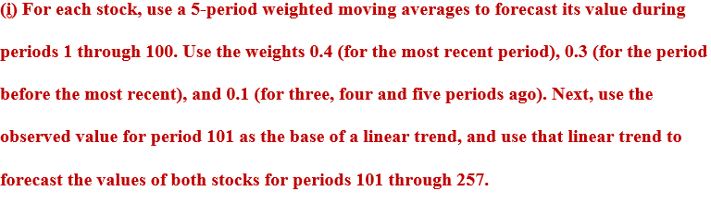

For long-term forecasting we are using a 5-period weighted moving average on the closing stock market value for both APPL & HON to calculate the trend-based forecasting value till the time period 100. After that we using a trend of what is happening till the period 257 and based on that trend performs a forecasting.

Here's a view at the APPL stock's Long-Term Forecasted graph, which shows an upward forecasting trend.

Here's a view at the HON stock's Long-Term Forecasted graph, which shows an upward forecasting trend.

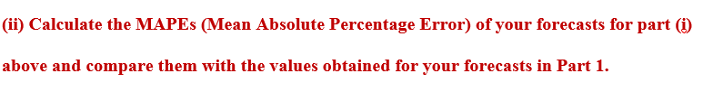

After we calculated our trend-based forecasting values we calculated the MAPE values for these long-term forecasting. To calculate the MAPE value we took out of the absolute value of difference between the forecasted value and the closing stock value for both the stocks divided by closing stock value. Finally, these values were represented as percentages. MAPE measures accuracy of a forecast system. In this instance, a 3.83% forecast means that the average difference between the forecasted value and the actual value is 3.83%.

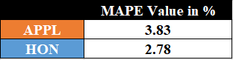

When we compare our MAPE value for long term forecasting with our short-term forecasting we can notice that MAPE value for short term forecasting is way lower than our long-term forecasting which was 1.94% and 1.86% respectively, which implies the absolute percentage error in large-term prediction is larger therefore short-term forecasting has yielded a better forecast. But, to determine whether this is a [good value for MAPE](https://www.statology.org/what-is-a-good-mape/) depends on the industry standards. If the standard model in the stock market industry produces a MAPE value of 2%, then this value of 3.83% might be considered high. Conversely, if most forecasting models in the stock market industry produce MAPE values between 10% and 15%, then a MAPE value of 3.83% may be considered low and this model may be considered excellent at forecasting future stock sales.

## Part Three: Regression

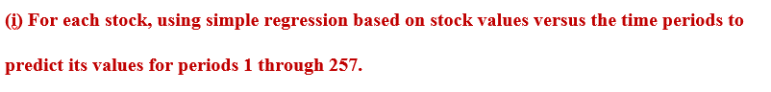

To illustrate the scatterplot between the independent variable x (time period) and dependent variable y (APPL closing stock), we used simple regression. A trend line was also created to indicate the APPL stock's upward trend. On the scatterplot, the equation of the line with the Coefficient of Determination was also shown.

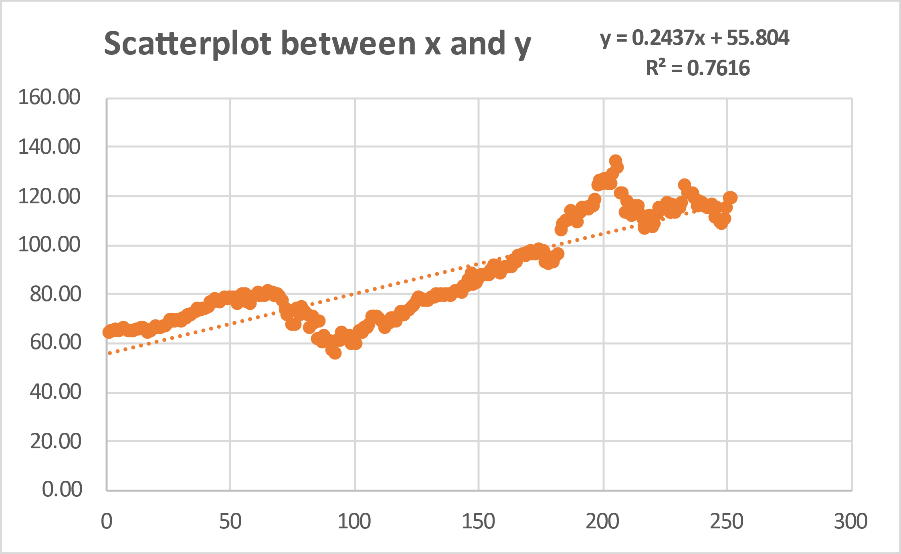

When compared to long-term forecasting, the predicted values for the APPL stock are significantly closer to the original value, while short-term forecasting values are much closer than simple regression values.

To illustrate the scatterplot between the independent variable x (time period) and dependent variable y (HON closing stock), we used simple regression. A trend line was also created to indicate the HON stock's upward trend. On the scatterplot, the equation of the line with the Coefficient of Determination was also shown.

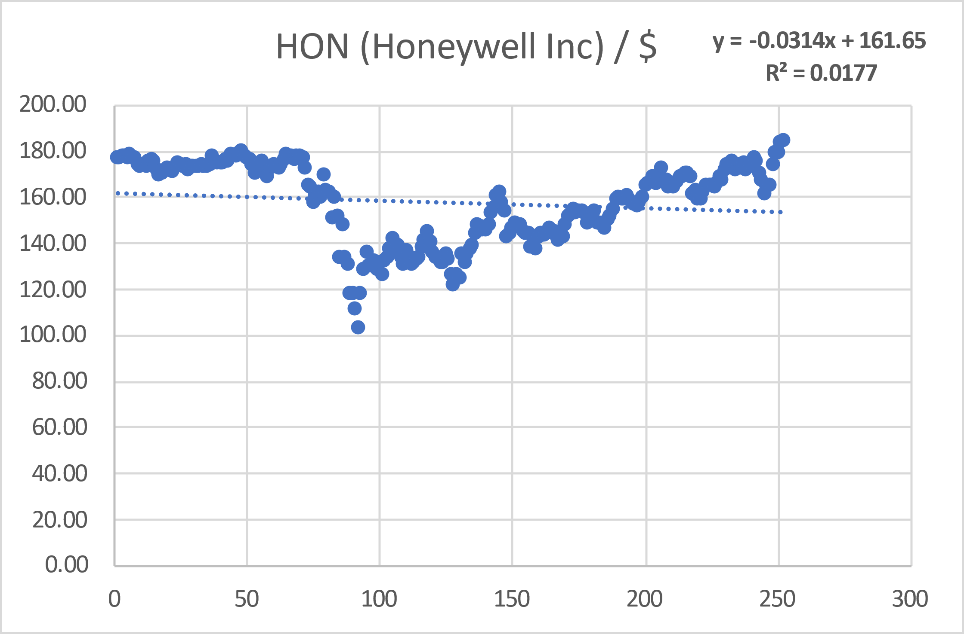

When comparing long term forecasting to simple regression predicted values for the HON stock, the predicted values are not substantially closer to the original value, and the same is true when comparing short term forecasting to simple regression predicted values.

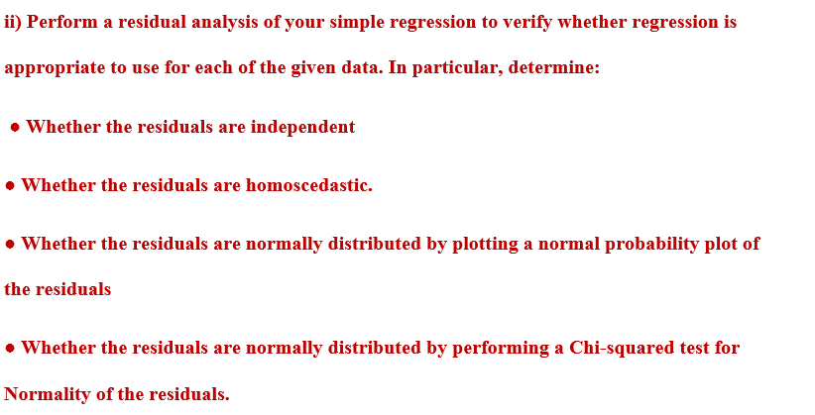

**APPL (Apple Inc) Stock**

When checking for independency we plot the residuals vs the independent variable (or time period if possible). There should not be any distinguishing pattern in the plot of the residual’s vs time. Because there is a distinguishing pattern, we are certain that the residual doesn’t meet the independency condition.

When checking for homoscedasticity we plot the residuals vs the predicted y values. There should not exist any pattern in the plot. Because there is a distinguishing pattern, we are certain that the residual doesn’t meet the homoscedasticity condition.

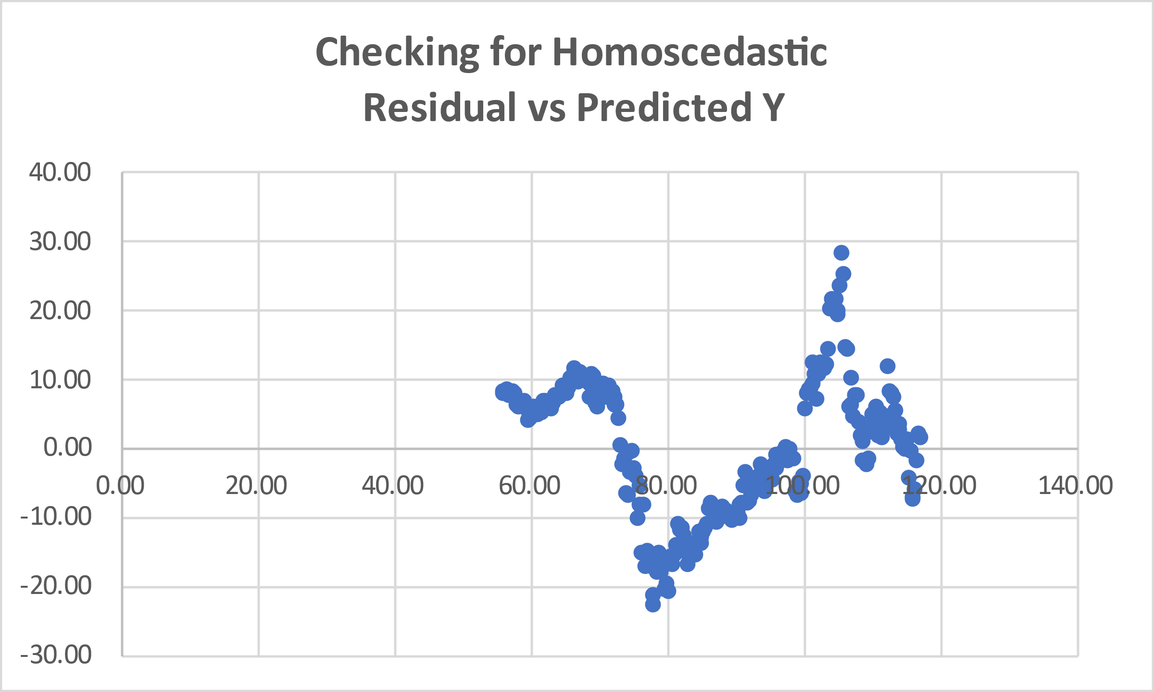

This plot describes the standardized residuals vs the standard values of the normal distribution. If we see a straight-line pattern, we can confirm that the two distributions do not have differences with each other which is true in this case as we can see almost a straight line. Which means that although there are some differences in our standardized residuals vs the standard values of the normal distribution but those differences are not significant enough. We can plot another line which is the orange line (standard value of the normal distribution) in this case to see how much deviation exist when compared with the blue line.

Because the P-value is significantly lesser than 0.05 we have enough evidence to reject the null hypothesis that the data is normally distributed.

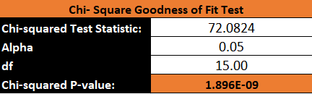

**HON (Honeywell Inc) Stock**

When checking for independency we plot the residuals vs the independent variable (or time period if possible). There should not be any distinguishing pattern in the plot of the residual’s vs time. Because there is a distinguishing pattern, we are certain that the residual doesn’t meet the independency condition.

When checking for homoscedasticity we plot the residuals vs the predicted y values. There should not exist any pattern in the plot. Because there is a distinguishing pattern, we are certain that the residual doesn’t meet the homoscedasticity condition.

This plot describes the standardized residuals vs the standard values of the normal distribution. If we see a straight-line pattern, we can confirm that the two distributions do not have differences with each other which is true in this case as we can see almost a straight line. Which means that although there are some differences in our standardized residuals vs the standard values of the normal distribution but those differences are not significant enough. We can plot another line which is the orange line (standard value of the normal distribution) in this case to see how much deviation exist when compared with the blue line.

Because the P-value is significantly lesser than 0.05 we have enough evidence to reject the null hypothesis that the data is normally distributed.

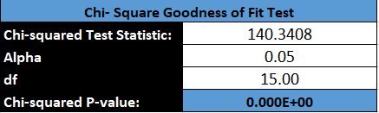

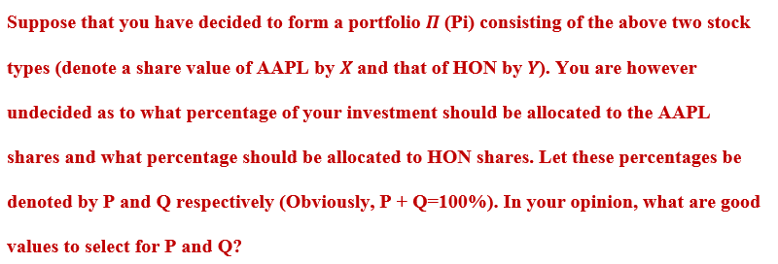

If we use X for the APPL share and Y for the HON share, we may use P and Q to represent each of their percentage numbers. In my opinion, if I had to invest all of my funds in one of these two stocks, I would put the majority of them in APPL Inc. because they have experienced continuous price growth as opposed to HON, which experienced steady price growth but only after experiencing declines for the majority of the first half of its stock closing price cycle. I will thus allocate 80–85 percent of my funds to the APPL stock(P) and 15–20 percent to the HON stock as a precaution (Q).

## CONCLUSION

I learnt about time series and forecasting methodologies while working on this project on time series forecasting. I worked with real-world stock data and learned how to use time series and forecasting techniques, including exponential smoothing and adjusted exponential smoothing for both short and long-term forecasting. I also learnt about MAD, MAPD, and MAPE values, as well as how to apply them to develop my forecasting model. Finally, I learnt how to do a simple regression analysis and a chi-square goodness of fit test on stock value data.

## REFERENCES

1) Addinsoft. (2022). Choosing an appropriate time series analysis method | XLSTAT Help Center. https://help.xlstat.com/6504-choosing-appropriate-time-series-analysis-method

2) An Investigation into Time Series Analysis | HPCC Systems. (2021). Hpccsystem. https://hpccsystems.com/blog/An_Investigation_into_Time_Series_Analysis

3) Z. (2020, May 21). How to Perform a Chi-Square Goodness of Fit Test in Excel. Statology. https://www.statology.org/chi-square-goodness-of-fit-test-excel/